The Joe Friday Award
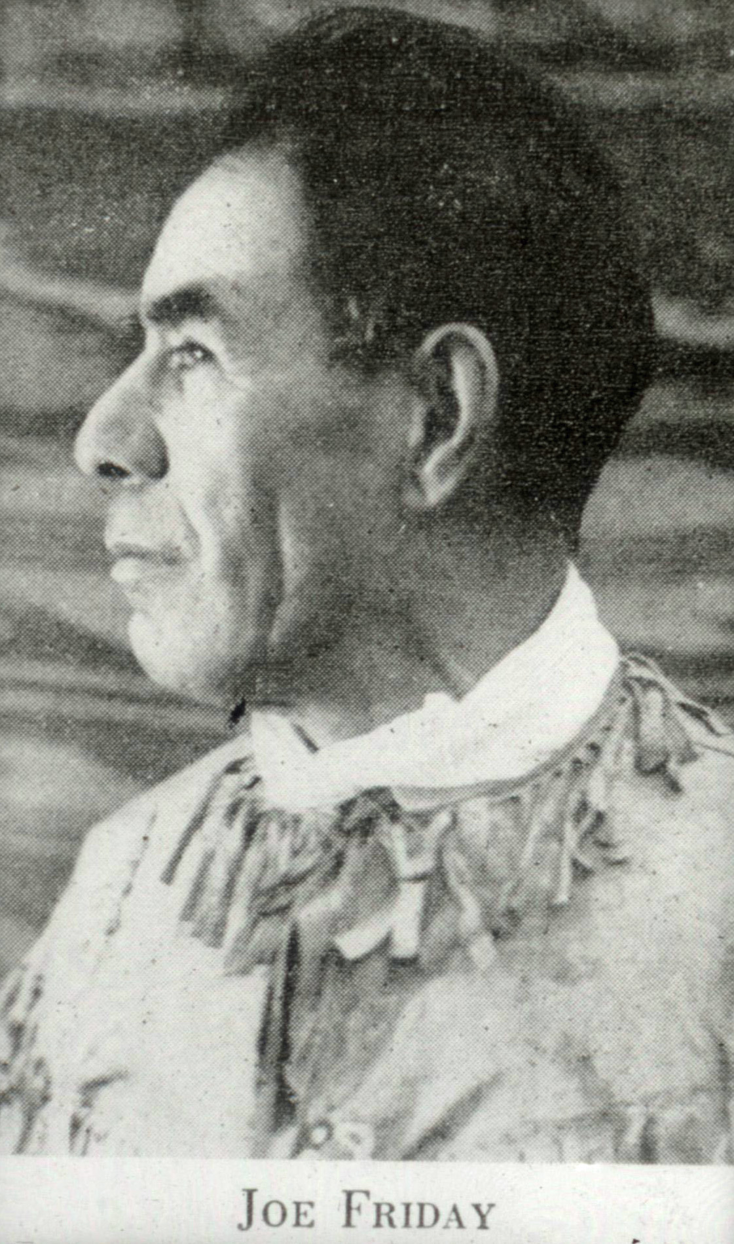The Joe Friday Award was established as recognition of extraordinary and outstanding service to the National Longhouse parent-child programs. Administered by the National Board of Elders, the award is named to honor the memory of Joe Friday, Ojibway Indian and close friend to Harold S. Keltner. Joe Friday was an instrumental part of the founding and development of the parent-child programs that began in 1926 and the inspiration of the Native American Theme. The procedures of this high honor award are as follows:
Purpose:
The Joe Friday Award signifies an extremely high honor and shall be awarded only to an individual who has given extraordinary personal services and dedication to the Native Sons and Daughters Programs.
Qualifications:
The following qualifications must be met by an individual who is to be considered for this award:
- The individual must be or have been an active member of or have significant connection to National Longhouse and the Native Sons and Daughters programs.
- The individual must have been instrumental and innovative in the development, advancement or promotion of their Local Longhouse, Regional Lodge or National Longhouse.
- The service given by this individual must have been extraordinary and must stand out as deserving of such high honor.
- The individual must be nominated from within their Local Longhouse or by persons at other levels of the National Longhouse organization.
- 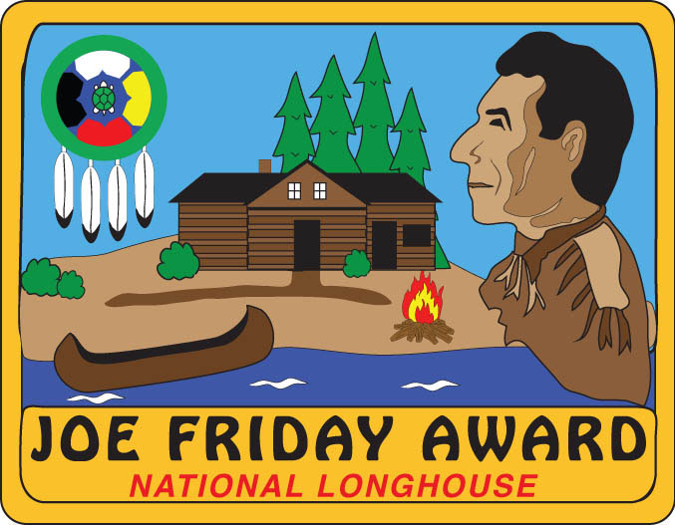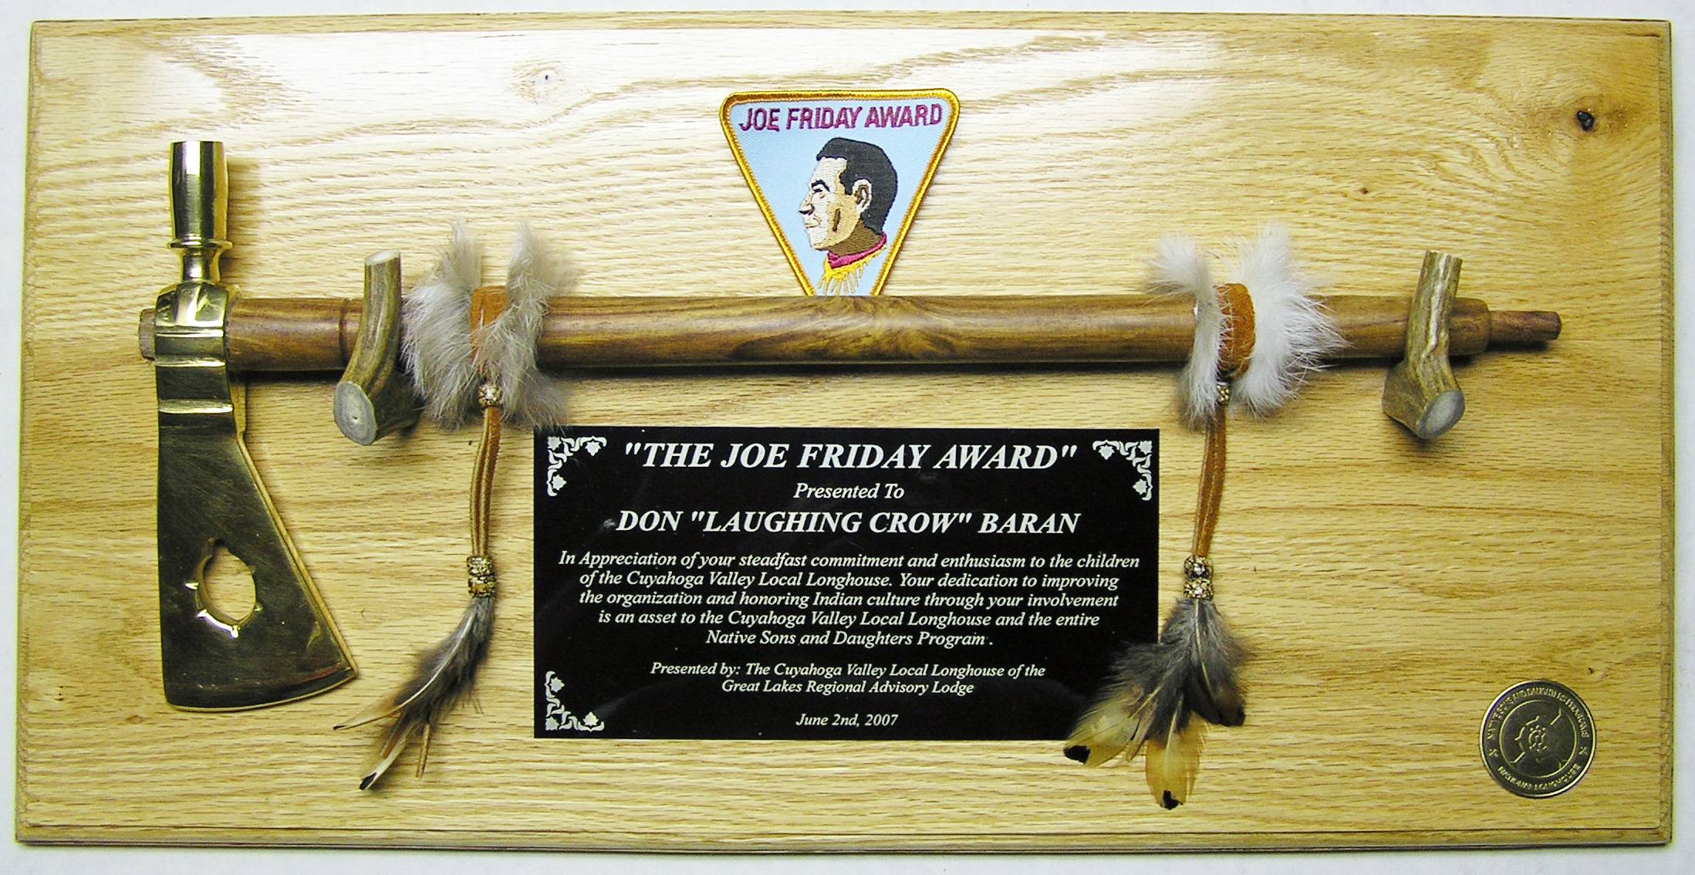The significance of this award is not to be diminished. It is not intended that this award be given as a standard for achievement such as completing a term of office (i.e. Longhouse Chief, etc.). Each nomination will be considered on its own merit.
Joe Friday Award Plaque and Patch
Procedures:
- Nomination forms shall be received by NLL no less than 60 days in advance of the intended presentation date to allow for review and approval.
- All nominations must be submitted on the Joe Friday Award form, pages 2 & 3 of this document. Email the completed form to NationalChief@nationallonghouse.org.
- A Local Longhouse, RAL or National Longhouse may nominate individuals as it deems necessary and appropriate.
- The award design is standardized by NLL but is personalized to reflect the name of the awardee and the Longhouse name (if applicable) and the month/year in which the award is planned to be presented.
- The award may be presented at a Longhouse gathering such as a campout ceremony, RAL meeting, NLL meeting etc., or other meeting as is appropriate.
- A National Longhouse officer or (other) officers may present the award or participate in the presentation of the award if desired and as schedules and logistics allow.
- The nomination and selection process shall be conducted by the most efficient means possible with sensitivity to the desired award presentation date.
- Approval will be by a majority of NLL Board of Elders available or responsible for approval of this award.
- National Longhouse sponsors the cost of the award and reasonable travel expense if an NLL officer(s) is to travel to present the award. The sponsoring body may be asked to reimburse additional travel costs as necessary.
The Joe Friday Award – Nomination Form
Instructions:
This form is to be used to nominate an individual to receive the Joe Friday Award. Qualifications for this award are detailed in the “procedures” statement on page one of this document. Please complete this form as it is provided and include all requested/pertinent information. Please submit the form (original if not emailed) as described in step 1 of the Procedures section.

Basic Nominee Information:
Name |  |  |  | Indian Name
Address
City |  |  |  | State |  |  |  | Zip
Longhouse Name
Active Member at present |  | ( ) Yes ( ) No-Retired |  | Detail if necessary:
Children(s) name(s) & Indian Names

Nomination Submitted By:
Name |  |  |  |  |  |  | Date:
Address
City |  |  | State |  |  |  | Zip
Phone (h) |  |  | Phone (w)
email |  |  | Phone (cell)
Longhouse Name (or other)
Position
Is this nomination made or supported by the Longhouse Council? |  |  |  |  |  | ( ) YES |  |  | ( ) NO
If above answer is NO, please explain in detail:

Desired Award Presentation Date (if known)
Desired Location for Award Presentation (if known)

Reason for Nomination:
On page 3, please provide a complete description (bio) of the nominee and of all activities that supported the National Longhouse Native Sons and Daughters Programs at a local, regional or national level to explain why this nominee should be awarded this high honor. Include all dates, timelines, positions held/served and the results of these actions that resulted in positive benefits to the Local Longhouse or other any other levels of the organization in which this individual has served. Involvement in other civic groups may be included, but only as supplemental information. The bio shall not exceed one page in length as provided on page 3.

Email the completed form to JoeFridayAward@nationallonghouse.org.

THIS SECTION FOR NATIONAL LONGHOUSE USE ONLY
DATE RECEIVED |  |  |  | RECEIVED BY:
REVIEWED BY:
ACCEPTED/CONFIRMED |  | YES ( ) NO ( ) |  |  |  | DATE
AWARD PRESENTATION BY
AWARD PRESENTATION DATE
The Joe Friday Award – Nominee Bio Page
Please provide a complete description (bio) of the nominee and of all activities that supported the National Longhouse Native Sons and Daughters Programs at a local, regional or national level to explain why this nominee should be awarded this high honor. Include all dates, timelines, positions held/served and the results of these actions that resulted in positive benefits to the Local Longhouse or other any other levels of the organization in which this individual has served.

