Council Fire Ceremony Closings
A Collection of Closing Parts
Overview: Council Fire Closings are as important as the rest of the ceremony. They wrap up a memorable council fire in a manner that seems to complete the package. They give thanks for the proceedings. They declare the council closed. This a collection of ceremonial closing parts that may be included in the end of a Longhouse council fire gathering. Some of these “parts” are included in the larger Induction Ceremony and other ceremonial script files. The Longhouse officer(s) conducting these parts can simply be determined by the Longhouse council that is organizing the ceremony. Use of a drumbeater during the ceremony and at the conclusion while people leave the circle adds to the authenticity overall.
Also, there are a number of Native American prayers that can be easily incorporated into a closing portion of a ceremony. These can be found in the Devotionals section of Rituals & Ceremonies for NSD Programs.

Participants:
- Officers as desired
- Drumbeater

Relevant Ceremonial Pieces: You may wish to incorporate this ceremony with other ceremonial components to form your full ceremony. The following are basic suggestions. Your creativity is your limit.
- Parade to Ceremonial Location
- Opening ceremony
- Inductions
- Officer Inductions
- Special Awards

CLOSING BENEDICTION IN NATIVE AMERICAN SIGN LANGUAGE #1
(Perhaps one of the oldest closing ceremony traditions and deeply rooted in the heritage of Native Sons & Daughters Programs, this spoken word and sign language closing ritual let’s all those gathered actively participate in the ritual. The ceremonial leader should have memorized and rehearsed the words and sign language to the prayer and able to lead it from memory. )
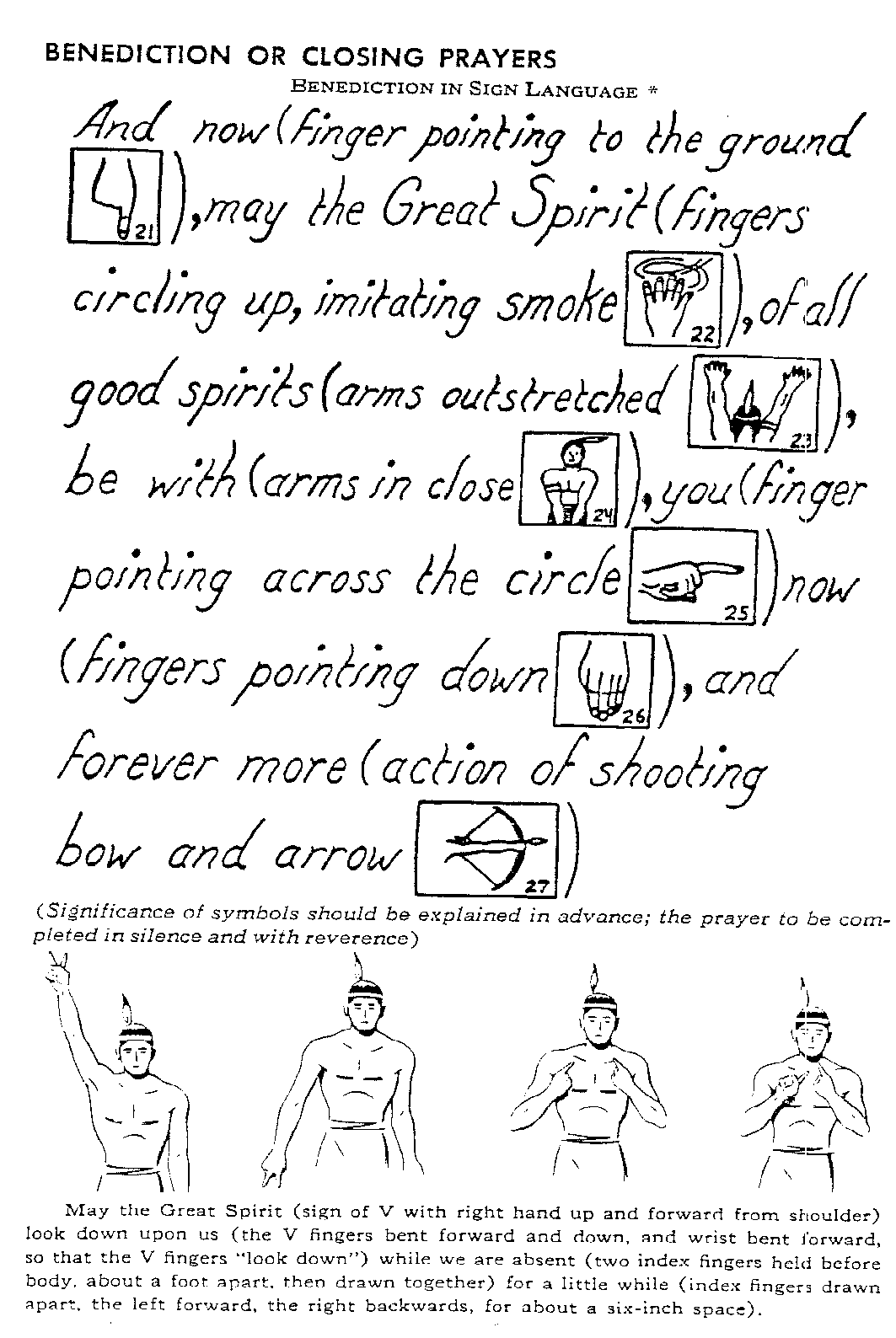

CLOSING BENEDICTION IN NATIVE AMERICAN SIGN LANGUAGE #2
(This closing benediction is also an old ritual, rooted in the heritage of Native Sone & Daughters Programs. This prayer is performed in silence but it is good to perform the symbols (one at a time) along with the meaning of each sign. Another option would be for an officers of the Longhouse council lead the signs and recite the words in reverence.)

CLOSING ODE TO THE 4 WINDS AND THE GREAT SPIRIT
(If there are fires lit to represent the 4 winds, the person reciting this would stand at each direction as they are spoken, then stand front and center for the final piece)
Oh Great Spirit of the East, where the sun always rises, lift up the hearts of all who might feel discouraged. Send wisdom to the hearts of all men and women. May each rising sun instill in them, the desire to be a friend of all.
Oh Great Spirit of the South, from whence comes the warm breezes, make clear the minds of all men and women. Help them to make broad and lasting decisions for the welfare of all.
Oh Great Spirit of the West, where the sun always sets and where the buffalo vanish, do not remove us from this earth until all things that should be done, are done.
Oh Great Spirit of the North, from whence comes the cold and long nights, make smooth the journey of all those who travel. May they reach the end of their journey in good health and good spirits.
All stand and recite the Native prayer… “Great Chief of the Universe, guide us until we meet again. (PERFORM SIGN LANGUAGE BENEDICTION #1 or #2) This council of the (Longhouse Name) Longhouse is closed. Go in peace until we meet again! (Shout Longhouse Salutation)

CLOSING ODE TO THE NATIVE AMERICAN AND NATIVE SONS & DAUGHTERS
Native American peoples of long ago, as well as today, were and are a very proud people. Proud of their families, proud of their heritage. Proud and caring of their lands, and have a deep belief in the guidance of the Great Spirit.
This time we have spent together symbolizes the passing of hopes, dreams, ideals, and heritage, from parent to child. A parent’s prayer for their child's success in life.
As Native Sons & Daughters, so to must we take pride in our fathers, our mothers, our families, our heritage. Realize that this time we parents and children have together is a special once-in-a-lifetime gift.
[PAUSE]
I have walked the land in the footsteps of my fathers, back in time to where the first one trod, stopped, saw sky, and felt wind, bent to the mother earth, and called this home.
To this earth and all its beauty, for which we must care, Home and Family, Mother, Father.
Grow too the seeds, the Sons and Daughters, to walk the old paths, to look back in pride, honored heritage.
To hear its laughter and its song, to grow to stand and be themselves one day remembered.
I have walked the land in the footsteps of all my fathers, I saw yesterday, stand here today, and look now to tomorrow.
This council of the (Longhouse Name) Longhouse is now ended! (Shout Longhouse salutation)

